WEEK 9
Development
9.1 Overview of DevOps
DevOps is a set of practices, tools, and a cultural philosophy that automate and integrate the processes between software development and IT teams. It emphasizes team empowerment, cross-team communication and collaboration, and technology automation.
The DevOps movement began around 2007 when the software development and IT operations communities raised concerns about the traditional software development model, where developers who wrote code worked apart from operations who deployed and supported the code. The term DevOps, a combination of the words development and operations, reflects the process of integrating these disciplines into one, continuous process.
DevOps is visualized as an infinite loop comprising the steps: plan, code, build, test, release, deploy, operate, monitor, then back to plan, and so on. DevOps emphasizes building trust and better liasioning between developers and system administrators. This helps the organization in aligning technological projects to business requirements. Changes rolled out are usually small and reversible, which the entire team begins to comprehend.
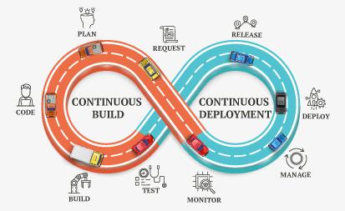

DevOps toolchains usually follow two approaches: an all-in-one or open toolchain. An all-in-one toolchain offers a complete solution that usually doesn’t integrate with other third-party tools, while an open toolchain allows for customization with different tools.
9.2 Working Principle
A DevOps team includes developers and IT operations working collaboratively throughout the product lifecycle, in order to increase the speed and quality of software deployment. It’s a new way of working, a cultural shift, that has significant implications for teams and the organizations they work for.
Under a DevOps model, development and operations teams are no longer “siloed.” Sometimes, these two teams merge into a single team where the engineers work across the entire application lifecycle — from development and test to deployment and operations — and have a range of multidisciplinary skills.
DevOps teams use tools to automate and accelerate processes, which helps to increase reliability. A DevOps toolchain helps teams tackle important DevOps fundamentals including continuous integration, continuous delivery, automation, and collaboration.
DevOps values are sometimes applied to teams other than development. When security teams adopt a DevOps approach, security is an active and integrated part of the development process. This is called DevSecOps.
9.3 Benefits
The benefits of DevOps include faster and easier releases, team efficiency, increased security, higher quality products, and consequently happier teams and customers.
- Speed
Teams that practice DevOps release deliverables more frequently, with higher quality and stability. In fact, the DORA 2019 State of DevOps report found that elite teams deploy 208 times more frequently and 106 times faster than low-performing teams. Continuous delivery allows teams to build, test, and deliver software with automated tools.
- Improved collaboration
The foundation of DevOps is a culture of collaboration between developers and operations teams, who share responsibilities and combine work. This makes teams more efficient and saves time related to work handoffs and creating code that is designed for the environment where it runs.
- Rapid deployment
By increasing the frequency and velocity of releases, DevOps teams improve products rapidly. A competitive advantage can be gained by quickly releasing new features and repairing bugs.
- Quality and reliability
Practices like continuous integration and continuous delivery ensure changes are functional and safe, which improves the quality of a software product. Monitoring helps teams keep informed of performance in real-time.
- Security
By integrating security into a continuous integration, continuous delivery, and continuous deployment pipeline, DevSecOps is an active, integrated part of the development process. Security is built into the product by integrating active security audits and security testing into agile development and DevOps workflows.
9.4 DevOps Culture
A DevOps culture is where teams embrace new ways of working that involve greater collaboration and communication. It’s an alignment of people, processes, and tools toward a more unified customer focus. Multidisciplinary teams take accountability for the entire lifecycle of a product.
Continuous learning
Organizations that do DevOps well are places where experimentation and some amount of risk-taking are encouraged. Where thinking outside the box is the norm, and failure is understood to be a natural part of learning and improving.
Agile
Agile methodologies are immensely popular in the software industry since they empower teams to be inherently flexible, well-organized, and capable of responding to change. DevOps is a cultural shift that fosters collaboration between those who build and maintain software. When used together, agile and DevOps result in high efficiency and reliability.
9.5 DevOps Practices: Continuous Integration
Continuous integration (CI) is the practice of automating the integration of code changes from multiple contributors into a single software project. It’s a primary DevOps best practice, allowing developers to frequently merge code changes into a central repository where builds and tests then run. Automated tools are used to assert the new code’s correctness before integration.
A source code version control system is the crux of the CI process. The version control system is also supplemented with other checks like automated code quality tests, syntax style review tools, and more.
9.5.1 The importance of continuous integration
In order to understand the importance of CI, it’s helpful to first discuss some pain points that often arise due to the absence of CI. Without CI, developers must manually coordinate and communicate when they are contributing code to the end product. This coordination extends beyond the development teams to operations and the rest of the organization. Product teams must coordinate when to sequentially launch features and fixes and which team members will be responsible.
The communication overhead of a non-CI environment can become a complex and entangled synchronization chore, which adds unnecessary bureaucratic cost to projects. This causes slower code releases with higher rates of failure, as it requires developers to be sensitive and thoughtful towards the integrations. These risks grow exponentially as the engineering team and codebase sizes increase.
Without a robust CI pipeline, a disconnect between the engineering team and the rest of the organization can form. Communication between product and engineering can be cumbersome. Engineering becomes a black box which the rest of the team inputs requirements and features and maybe gets expected results back. It will make it harder for engineering to estimate time of delivery on requests because the time to integrate new changes becomes an unknown risk.
What CI does?
CI helps to scale up headcount and delivery output of engineering teams. Introducing CI to the aforementioned scenario allows software developers to work independently on features in parallel. When they are ready to merge these features into the end product, they can do so independently and rapidly. CI is a valuable and well-established practice in modern, high performance software engineering organizations.
How CI can be used?
CI is generally used alongside an agile software development workflow. An organization will compile list of tasks that comprise a product roadmap. These tasks are then distributed amongst software engineering team members for delivery. Using CI enables these software development tasks to be developed independently and in parallel amongst the assigned developers. Once one of these tasks are complete, a developer will introduce that new work to the CI system to be integrated with the rest of the project.
9.5.2 Benefits and challenges of continuous integration
Continuous integration is an essential aspect of DevOps and high-performing software teams. Yet CI benefits are not limited to the engineering team but greatly benefit the overall organization. CI enables better transparency and insight into the process of software development and delivery. These benefits enable the rest of the organization to better plan and execute go to market strategies. The following are some of the overall organizational benefits of CI.
- Enable scaling
CI enables organizations to scale in engineering team size, codebase size, and infrastructure. By minimizing code integration bureaucracy and communication overhead, CI helps build DevOps and agile workflows. It allows each team member to own a new code change through to release. CI enables scaling by removing any organizational dependencies between development of individual features. Developers can now work on features in an isolated silo and have assurances that their code will seamlessly integrate with the rest of the codebase, which is a core DevOps process.
- Improve the feedback loop
Faster feedback on business decisions is another powerful side effect of CI. Product teams can test ideas and iterate product designs faster with an optimized CI platform. Changes can be rapidly pushed and measured for success. Bugs or other issues can be quickly addressed and repaired.
- Enhance communication
CI improves overall engineering communication and accountability, which enables greater collaboration between development and operations in a DevOps team. By introducing pull request workflows tied to CI, developers gain passive knowledge share. Pull requests allow developers to observe and comment on code from other team members. Developers can now view and collaborate on feature branches with other developers as the features progress through the CI Pipeline. CI can also be used to help QA resource expenses. An efficient CI pipeline with high-confidence automated test coverage will safeguard from regressions and ensure that new features match a specification. Before new code is merged it must pass the CI test assertion suite which will prevent any new regressions.
The benefits of CI far outweigh any challenges in adoption. That said, it is important to be aware of the challenges of CI. The real challenges of CI arise when transitioning a project from no CI to CI. Most modern software projects will adopt CI from early inception stages and alleviate the challenges of later adoption.
- Adoption and installation
The challenges of continuous integration are primarily around team adoption and initial technical installation. If a team doesn't currently have a CI solution in place, it can require some effort to pick one and get started. Thus, considerations need to be made around the existing engineering infrastructure when installing a CI pipeline.
- Technology learning curve
CI functionality comes with a list of supportive technologies that may be learning curve investments for the team to undertake. These technologies are version control systems, hosting infrastructure, and orchestration technologies.
9.6 Continuous Delivery
Continuous delivery is an approach where teams release quality products frequently and predictably from source code repository to production in an automated fashion.
Some organizations release products manually by handing them off from one team to the next, which is illustrated in the diagram below. Typically, developers are at the left end of this spectrum and operations personnel are at the receiving end. This creates delays at every hand-off that leads to frustrated teams and dissatisfied customers. The product eventually goes live through a tedious and error-prone process that delays revenue generation.
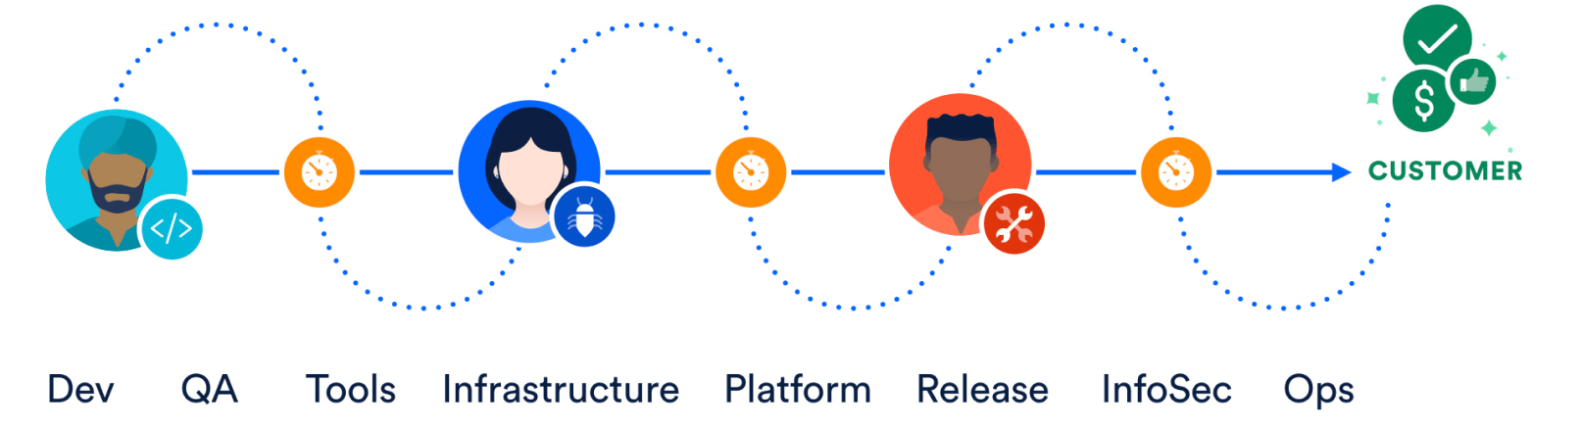
Figure: Manual Release of Products to Customers
Now, check out the continuous delivery pipeline below. It illustrates how developers write code on their laptops and commit changes to a source code repository, like Bitbucket. By code, we mean the system under test, the tests, and the infrastructure used to deploy and maintain the system. Bitbucket Pipelines can ship the product from test to staging to production, and help customers get their hands on those shiny new features.

Figure: Continuous Delivery Pipeline Doing Automated Releases
9.6.1 Value of Continuous Delivery
The software delivery pipeline is a product in its own right and should be a priority for businesses. Otherwise, we should not send revenue-generating products through it. Continuous delivery adds value in three ways. It improves velocity, productivity, and sustainability of software development teams.
- Velocity
Velocity means responsible speed and not suicidal speed. Pipelines are meant to ship quality products to customers. Unless teams are disciplined, pipelines can shoot faulty code to production, only faster! Automated software delivery pipelines help organizations respond to market changes better.
- Productivity
A spike in productivity results when tedious tasks, like submitting a change request for every change that goes to production, can be performed by pipelines instead of humans. This lets scrum teams focus on products that wow the world, instead of draining their energy on logistics. And that can make team members happier, more engaged in their work, and want to stay on the team longer.
- Sustainability
Sustainability is key for all businesses, not just tech. “Software is eating the world” is no longer true, software has already consumed the world! Every company at the end of the day, whether in healthcare, finance, retail, or some other domain, uses technology to differentiate and outmaneuver their competition. Automation helps reduce/eliminate manual tasks that are error-prone and repetitive, thus positioning the business to innovate better and faster to meet their customers' needs.
9.7 Version Control
Version control is the practice of managing code in versions—tracking revisions and change history to make code easy to review and recover. This practice is usually implemented using version control systems such as Git which allow multiple developers to collaborate in authoring code. These systems provide a clear process to merge code changes that happen in the same files, handle conflicts and roll back changes to earlier states.
The use of version control is a fundamental DevOps practice, helping development teams work together, divide coding tasks between team members and store all code for easy recovery if needed. Version control is also a necessary element in other practices such as continuous integration and infrastructure as code.
A configuration management platform uses human and machine-readable text files written in a markup language like YAML to declare tasks and sequences for the platform to execute. These text files can be treated like application code files and stored in a version control system repository. The repository acts as a central source of truth and enables pull requests and code review. The most popular version control system is Git.
With these dependencies in place, let's consider an example scenario in which a developer wants to add a new application service to a system. This scenario helps demonstrate an IaC workflow
- The developer edits a YAML configuration text file in their configuration management platform of choice, Terraform. The edits specify that a new hosting server is needed.
- The developer commits edits to a feature branch in the Git repository. Because the project's Git repository is hosted on Bitbucket, the developer opens up a pull request. Another team member reviews the pull request and becomes aware of the new infrastructure changes. The team member approves the pull request and the developer then merges the commit to the main branch of the repository.
- At this point, the configuration platform is needed to execute an update. The update can be manually triggered by the developer. Because the team is using Bitbucket they also have access to Bitbucket Pipelines and can automate this step with a pipeline.
- Upon execution Terraform interfaces with the team's IaaS. Terraform executes a series of commands against the IaaS API to bring the IaaS up to date with the expected infrastructure configuration.
9.8 Configuration Management
Configuration management refers to managing the state of resources in a system including servers, virtual machines and databases. Using configuration management tools, teams can roll out changes in a controlled, systematic way, reducing the risks of modifying system configuration. Teams use configuration management tools to track system state and help avoid configuration drift, which is how a system resource’s configuration deviates over time from the desired state defined for it.
Practiced in conjunction with infrastructure as code, both system definition and configuration are easy to templatise and automate, helping teams operate complex environments at scale.
9.9 Build Process
A microservices architecture, also simply known as “microservices”, is an approach to building an application as a series of independently deployable services that are decentralized and autonomously developed. These services are loosely coupled, independently deployable, and easily maintainable. While a monolithic application is built as a single, indivisible unit, microservices break that unit down into a collection of independent units that contribute to the larger whole. Microservices are an integral part of DevOps, since they are the basis for continuous delivery practices that allow teams to adapt quickly to user requirements.
Benefits of Microservices are:
- Agility
Since small, independent teams typically build out a service within microservices, it encourages teams to adopt agile practices. Teams are empowered to work independently and move quickly, which shortens development cycle times.
- Flexible Scaling
Since microservices are distributed by design and can be deployed in clusters, they enable dynamic horizontal scaling across service boundaries. If a microservice reaches its load capacity, new instances of that service can rapidly be deployed to the accompanying cluster to help relieve pressure.
- Frequent Releases
One of the primary advantages of microservices is frequent and faster release cycles. As a key element of continuous integration and continuous delivery (CI/CD), microservices allow teams to experiment with new features and roll back if something doesn’t work. This makes it easier to update code and accelerates time-to-market for new features.
- Technology Flexibility
Microservice architectures don’t necessarily follow a set approach with one toolchain but allow teams the freedom to select the tools they desire.
- Focus on Quality
The separation of business concerns into independent microservices means that the service team owning that service focuses on the completed quality deliverable.
- High Reliability
By separating functionality, microservices reduce the risk of breaking an entire application or code base when releasing updates. It is easy to isolate and fix faults and bugs in individual services. You can deploy changes only for a specific service, without bringing down the entire application, which provides higher reliability.
LAB ACTIVITY
- Create Git (similar tool) account and configure repository
GitHub Account Creation:
Step 1: To create Git account, go to official web page https://github.com/ and fill in the registration form.
Step 2: Pick a username (e.g., octocat123), enter your email address and a password, and click Sign up for GitHub.
Git Installation
Step 1: Download the latest Git for Windows from link https://gitforwindows.org/.
Step 2: Go to the folder where new downloads gets store i.e., Download folder. Double click on the installer. When the installer begins, follow the Next and Finish prompts to complete the installation. The default options are pretty sensible for most users.
Step 3: We may like to keep the installation to another folder, so here is the chance to do so. Or else just keep it in the suggested default folder “Program Files\Git”.
Step 4: During process, we recommend to choose the option of “Checkout Windows-style, commit Unix-style line endings”. Select next once the said option is choosen.
Step 5: Just go with default selections, and click on next on upcoming window.
Step 6: Once everything is done, just click on Finish button.
Step 7: In order to verify if the installation went well for Git. Go to cmd and type git (or git --version)and press enter. you should get the following output on the screen.
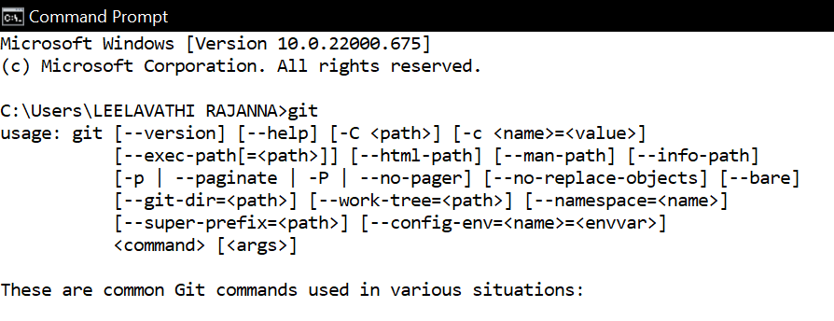
NOTE: At last; run the following commands in terminal with your information to set a default username and email, which in turn is used to save your work:
$ git config --global user.name "Madhu"
$ git config --global user.email "madhu@mail.com"
Create a New Repository
Step 1: A repository is like a place or a container where something is stored; in this case we're creating a Git repository to store code. To create a new repository, select New Repository from the + sign dropdown menu.
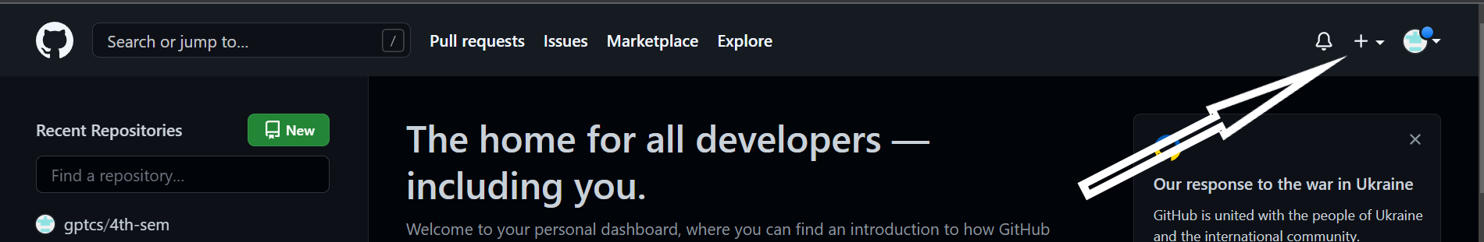
Step 2: Enter a name for repository (e.g, "Demo"), put a small description and click Create Repository. Don't worry about changing any other options on this page.
Step 3: In order to see all your repositories, click on the profile picture in the menu bar and then on “Your repositories”.
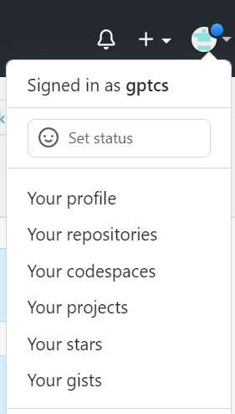

- Upload the artifacts created to Git Learn version control and configuration management with Git.
Create a file
Step 1: Once your repo is created, it will look like this:
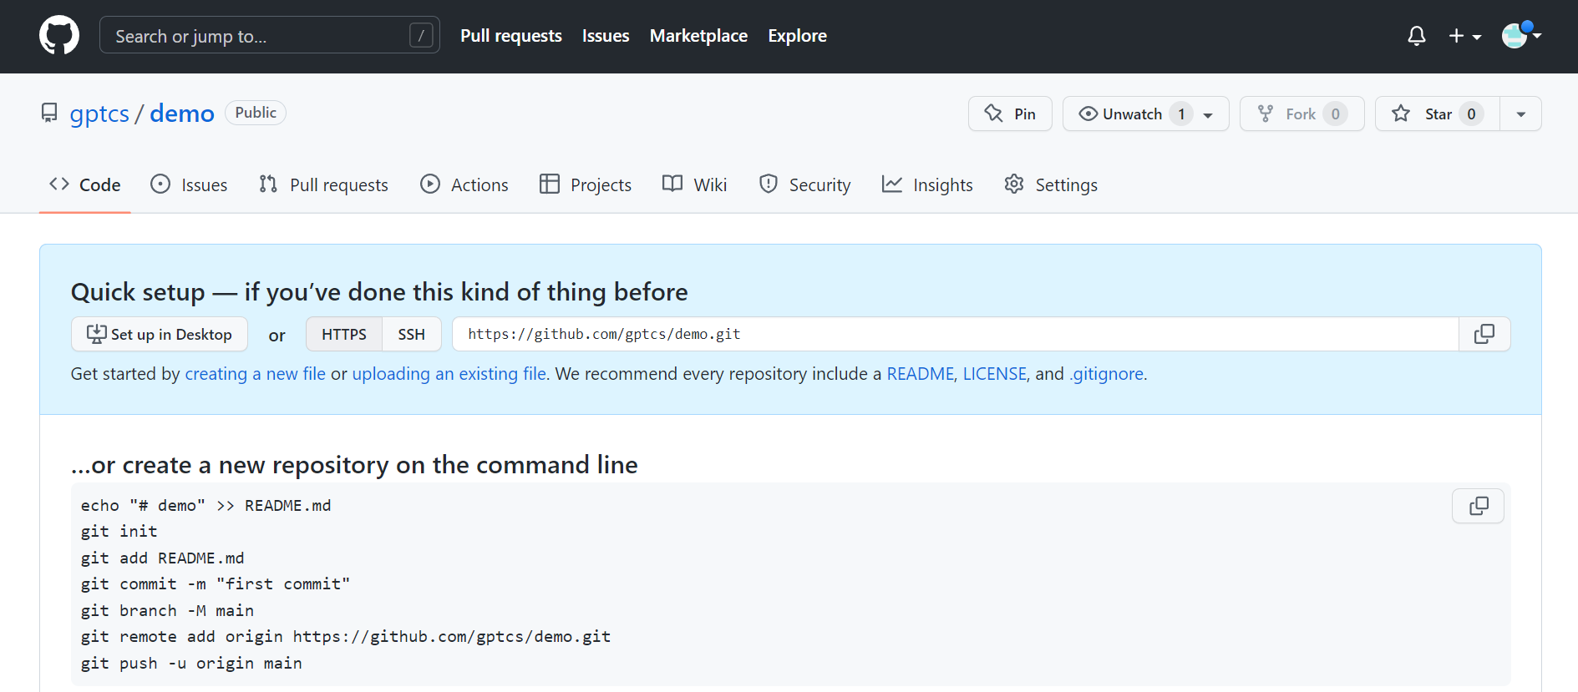

Step 2: Open the Terminal program on your computer. In the terminal, type: “mkdir Demo” command. This command will create a directory (or folder) named Demo.
Note: Make sure that git is been installed on your computer by typing git –version in the command prompt. Before proceeding further.

Step 3: Change the terminal to the Demo directory with the command: “cd Demo”. Then enter:
echo "Polytechnic College" >> README.md
Step 4: This creates a file named README.md and writes Polytechnic College in it. To check that the file was created successfully, enter: ”type README.md”
Step 5: This will show you what is inside the README.md file, if the file was created correctly. Then the terminal will look like this:
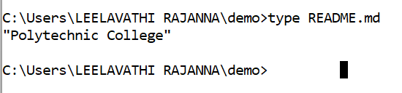
Step 6: To tell the computer that Demo is a directory managed by the Git program, enter: “git init”.
Step 7: Then, to tell the Git program that we care about this file and want to track any changes from this point forward, enter: “git add README.md”.
Make a Commit
So far we've created a file and told Git about it, and now it's time to create a commit. Commit can be thought of as a milestone. Every time we accomplish some work, we can write a Git commit to store that version of our file, so we can go back later and see what it looked like at that point in time. Whenever we make a change to our file, we create a new version of that file, different from the previous one. To make a commit, enter:
git commit -m "first commit"
We just created a Git commit and included a message that says first commit. We must always write a message in commit; it not only helps to identify a commit, but it also enables us to understand what we did with the file at that point. So tomorrow, if we add a new piece of code in our file, we can write a commit message that says, Added new code, and when we come back in a month to look at our commit history or Git log (the list of commits), we will know what we changed in the files.
Connect your GitHub repo with your computer
Step 1: Now, it's time to connect your computer to GitHub with the command: “git remote add origin https://github.com/<your_username>/Demo.git” . In our example it is “git remote add origin https://github.com/gptcs/Demo.git”
Step 2: This allows us to interact with Git repository on GitHub.com by typing origin instead of the full URL and Git will know where to send the code. Now we have connected our local copy of the Demo repository to its remote counterpart on GitHub.com. Our terminal looks like this:

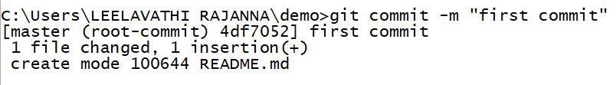
Step 3: Now that we have added the remote, we can push our code (i.e., upload our README.md file) to GitHub.com. by typing “git push -u origin master”. Once it is done, the terminal will look like this:

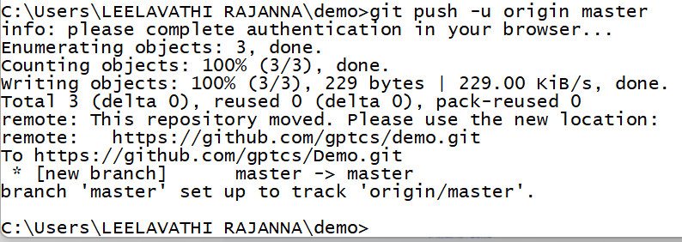

Step 4: Finally go to URL in browser https://github.com/<your_username>/Demo, It should look something like this:

